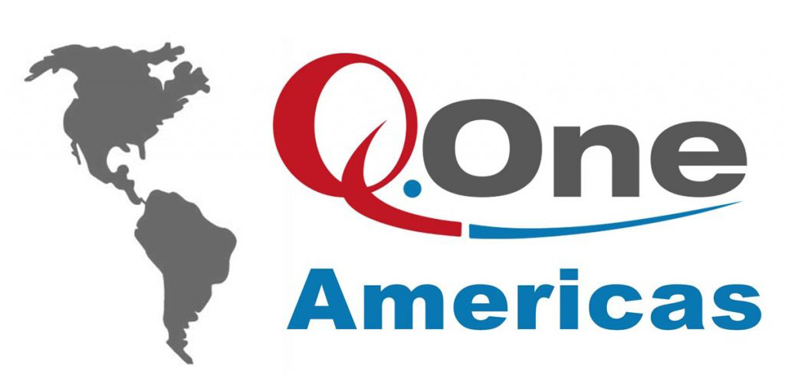
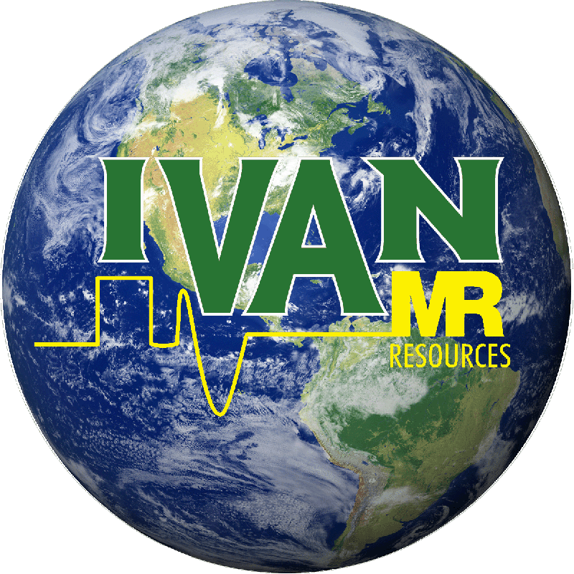
IVAN NMR Users Group
Sponsored by MR Resources and Q.One Americas

May 11, 2020

Our Second International IVAN Online-ZoomTM Meeting, Wednesday May 20th, 2020 at 12:00 Noon EDT.

“Looking Toward Post-pandemic NMR Operations”

A Discussion of our NMR Laboratory Planning for Reopening.

On Wednesday May 20th^{th} the IVAN NMR group will host our second online-ZoomTM meeting for discussion of NMR operations during the global COVID pandemic. The focus of this meeting will be the ongoing planning to reopen that is taking place at all of our institutions, whether they are universities, business or government.
For this meeting, we have invited Ken Knott of Virginia Tech to lead the discussion. Recently, Ken posted an email to AMMRL members asking for their responses about planning at their institutions. To-date he has received more than 50 replies. Ken plans to focus the discussion on these replies. If you submitted a posting certainly plan to be at the meeting to discuss it! Our first meeting had more than 80 attendees. If you missed the first meeting, certainly join us for this second! Ken will also post the usual summary of replies at AMMRL.
This invitation goes out to all IVAN members, AMMRL members and all other interested NMR users across the world. Note that the meeting time is now at Noon EDT (GMT -4). Apologies to our western-pacific users – we hope to still see you early!
To attend, click on the link below to register with your name and email. After registration, you will receive an immediate reply with the link to the meeting itself. Click that link on Wednesday May 20th to join us. Note that this invitation to register can be passed on to anyone by email, but the meeting link you receive is specific to you.
Our goal continues to be to make our online platform regularly available to NMR users for discussions, research presentations and tutorial workshops. If you are not already an IVAN member consider joining at the website, http://www.ivanmr.com, so as to receive future meeting announcements directly. IVAN membership is free of charge and open to all interested NMR users.
You are invited to a Zoom meeting.
When: May 20, 2020 Noon Eastern Time (US and Canada)
Register in advance for this meeting:
https://us02web.zoom.us/meeting/register/tZ0pd--urDIrEtZ1KyCTdkYIvk0WIdAPEzHj

Stay healthy and see you online!

The 2020 Executive Committee of IVAN: Tim Burrow, Craig Butts, Frank Delaglio, George Gray, Dan Iverson, Krish Krishnamurthy, Dave Rice, Dave Russell, Mike Strain, Don Bouchard (Q.One Americas, Indianapolis), Marty Marek (Q.One Americas, Chicago), Jeremy Lea (MRR Europe and Scientific Magnetics), Ramon Rosales (MRR Mexico), Shellie Hammond (MRR) and Jon Webb (CEO of MRR and VP of Q.One Americas)

