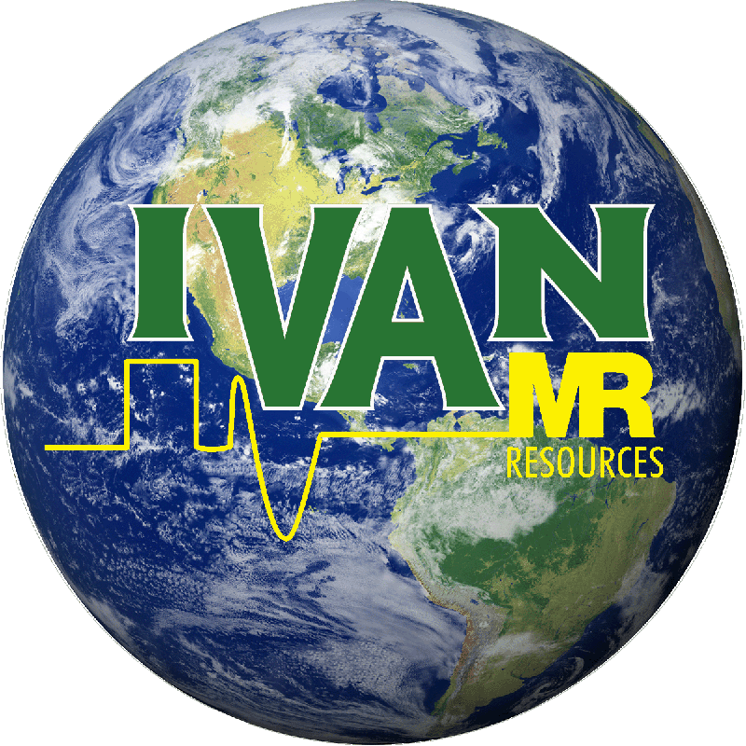
International Varian-Agilent NMR
Users Group
Sponsored by MR Resources

April 21, 2020

A First International IVAN Online-ZoomTM Meeting, Wednesday April 29th, 2020 at 1:00 PM EDT.

“NMR Operations During the COVID Pandemic”

Share Your Stories about NMR Lab Operation During the Shelter-In-Place.

On Wednesday April 29th^{th} the IVAN NMR group will host an online-ZoomTM “Town Meeting” for those of you interested in sharing how you are maintaining your NMR facilities during the global COVID pandemic. We seek input from you about your facilities, large and small, academic and industrial, to share how you are managing operations and users' needs. Bring your stories to the discussion!

This invitation goes out to IVAN members and all other interested NMR users. Let’s compare our experiences in different states of the USA and countries across the world. Last week we held a first Zoom meeting of this type with a panel of participants from the 2020 ENC IVAN meeting. We discussed the status of our labs, service and cryogen availability and we began a discussion of ideas for reopening and remote operation. Our small group of participants represented academia, business and government. Join us for the larger discussion!

While the topic of this meeting is NMR and the COVID pandemic, let’s also think about what more we can do with IVAN meetings online. All scientific communication and meetings will probably be moving in an online direction. Our goal here is to make this new IVAN platform regularly available to NMR users for discussions, research presentations and tutorial workshops. Let’s talk about topics for future meetings.

To attend, click on the link below to register with your name and email. After registration, you will receive an immediate reply with the link to the meeting itself. Click that link on Wednesday April 29th to join us. We have put some serious work into Zoom meeting management and security!

You are invited to a Zoom meeting.
When: Apr 29, 2020 01:00 PM Eastern Time (US and Canada)
Register in advance for this meeting:
https://zoom.us/meeting/register/tJ0lcuCgqj0oHd0x2gPbbLTQHOOBRw7S7GHc

Stay healthy and see you online!

The 2020 Executive Committee of IVAN: Tim Burrow, Craig Butts, Frank Delaglio, George Gray, Dan Iverson, Krish Krishnamurthy, Dave Rice, Dave Russell, Mike Strain, Don Bouchard (Q One Americas, Indianapolis), Marty Marek (Q One Americas, Chicago), Jeremy Lea (MRR Europe and Scientific Magnetics), Ramon Rosales (MRR Mexico), Shellie Hammond (MRR) and Jon Webb (CEO of MRR and VP of Q One Americas)

